CLASS DIAGRAM:

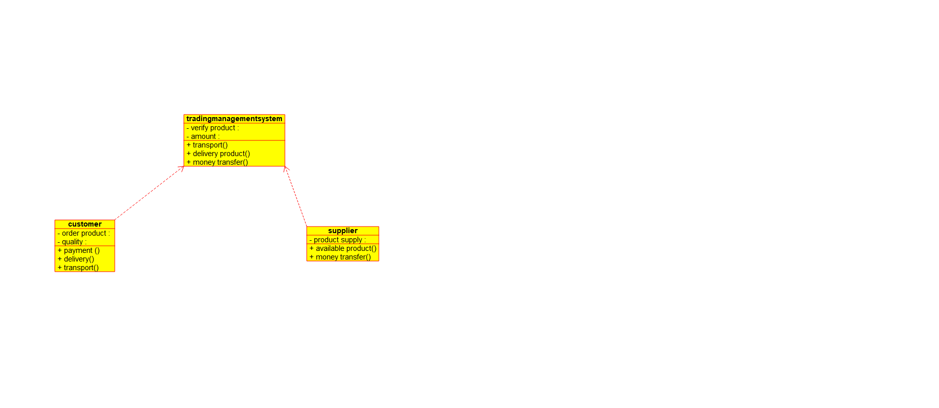

COLLOBARATION DIAGRAM:

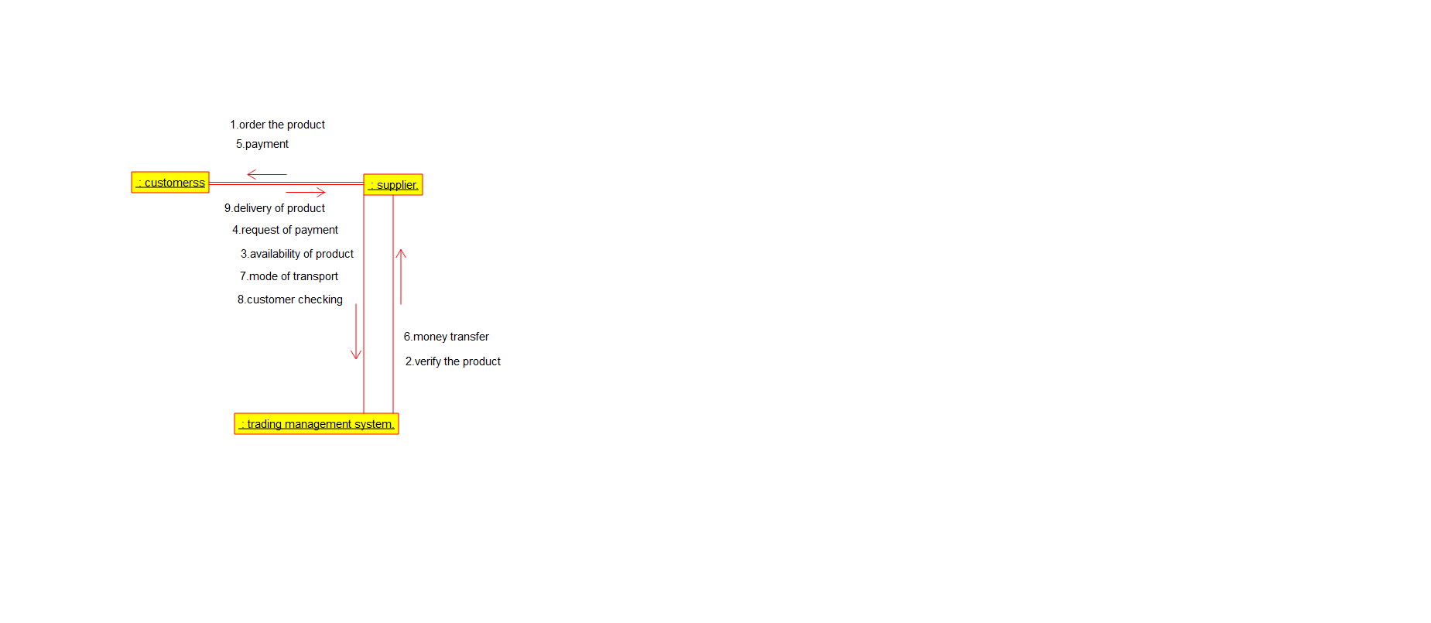

SEQUENCE DIAGRAM:

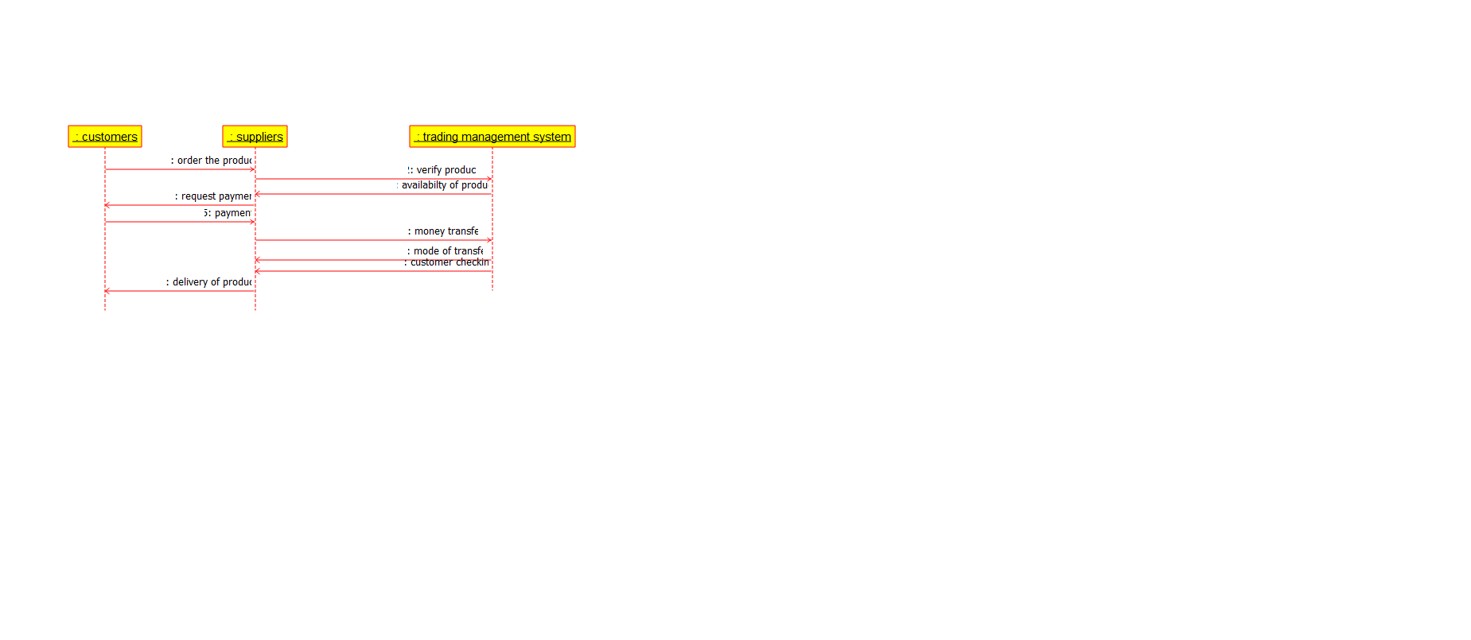

USECASE DIAGRAM:

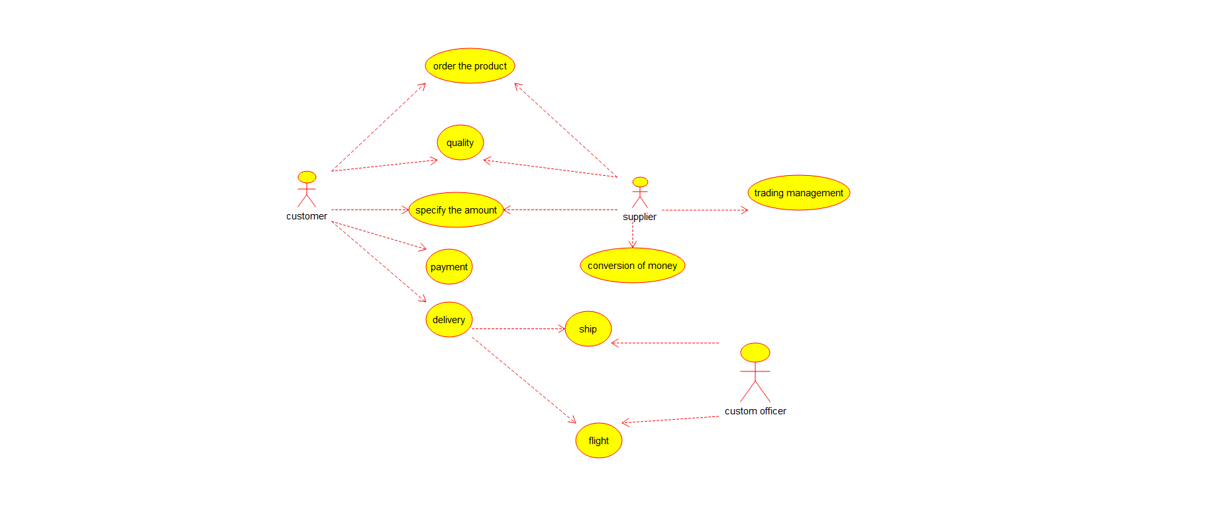

STATE DIAGRAM:

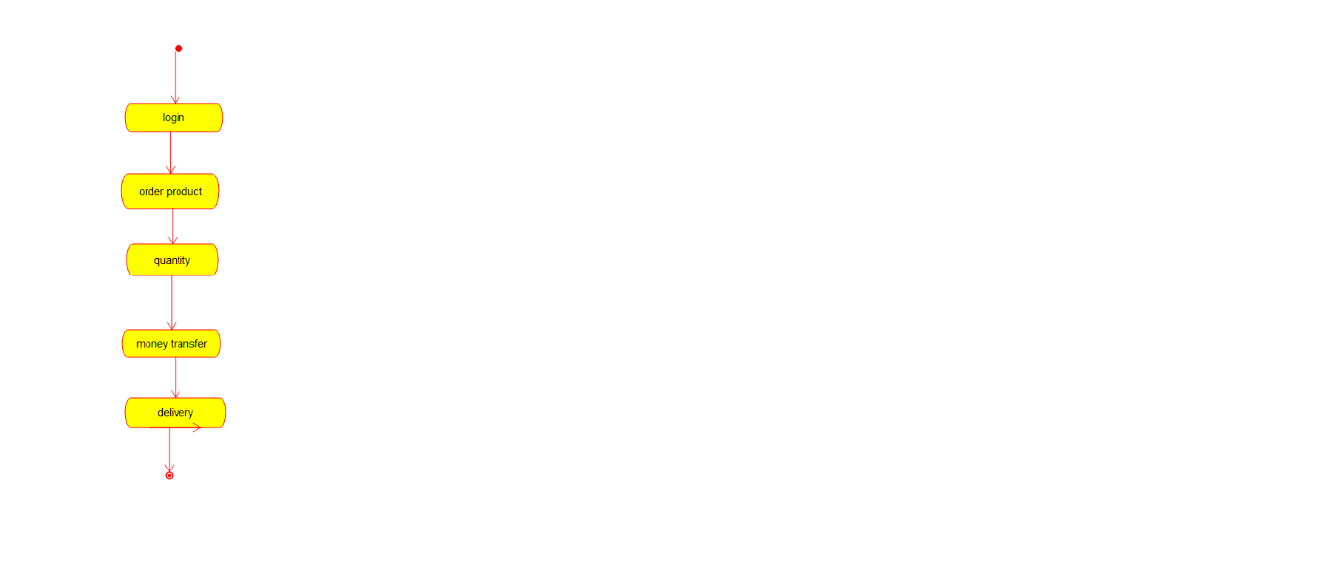

COMPONENT DIAGRAM:

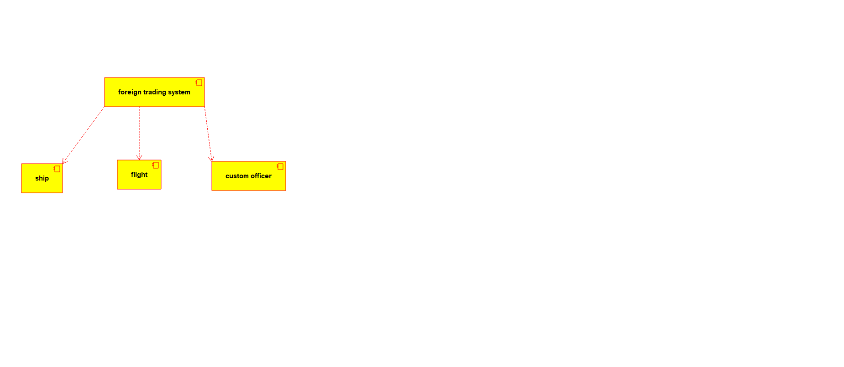

DEPLOYMENT DIAGRAM:

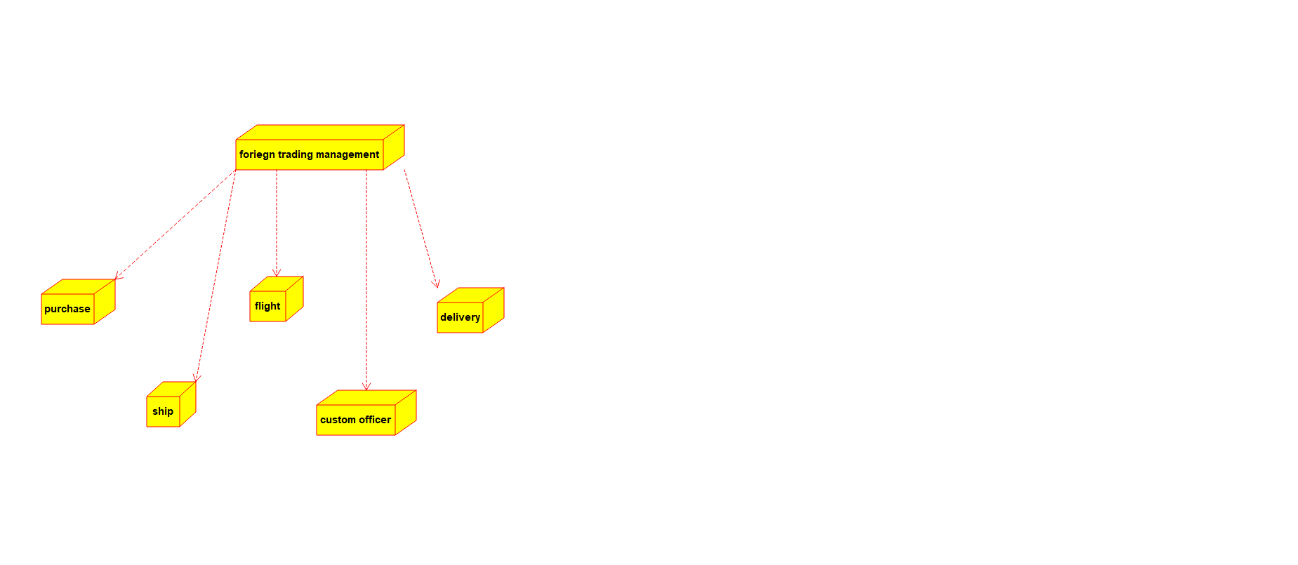

ACTIVITY DIAGRAM:

